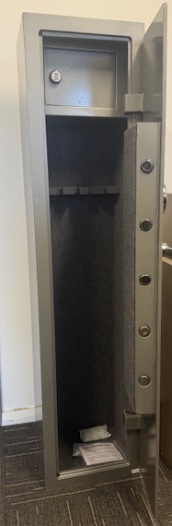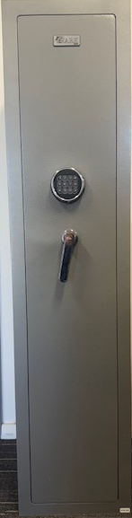

Ironguard Shark 5 Rifle Safe: Premium Security for Your Firearms
The Ironguard Shark 5 is a Level 2-rated firearm safe, engineered for maximum security and durability. Designed to protect up to 5 rifles, this safe combines heavy-duty steel construction with advanced locking mechanisms to provide peace of mind for the serious collector.
Key Specifications:
- Security Rating: Level 2 Firearm Safe.
- Construction: 10mm solid steel door and 10mm steel body for superior impact resistance.
- Bolt Work: Heavy-duty 32mm solid locking bolts.
- Locking System: High-security digital keypad for the main door; dedicated internal ammunition compartment with a separate electronic lock.
- Capacity: Secure storage for up to 5 rifles.

Dimensions:
- External: 1500mm (H) x 350mm (W) x 350mm (D)
- Internal: 1240mm (H) x 330mm (W) x 260mm (D)
- Ammo Compartment: 240mm (H) x 330mm (W) x 185mm (D)
- Weight: 175kg
Professional Features & Benefits:
- Anti-Tamper Protection: Advanced bolt work and heavy-duty steel thickness provide excellent resistance against pry attacks and physical tampering.
- Dual-Locking System: Ensures that ammunition remains stored separately from firearms, adhering to strict safety compliance standards.
- Durable Finish: High-quality, scratch-resistant powder coating designed to withstand long-term use and environmental wear.
- Internal Protection: Fully lined interior to prevent scratches and damage to rifle stocks and finishes.
- Floor Anchoring: Pre-drilled bolt-down holes included to ensure the safe can be securely fastened to the floor for maximum stability and theft deterrence.

